Median Of medians:

CODE:

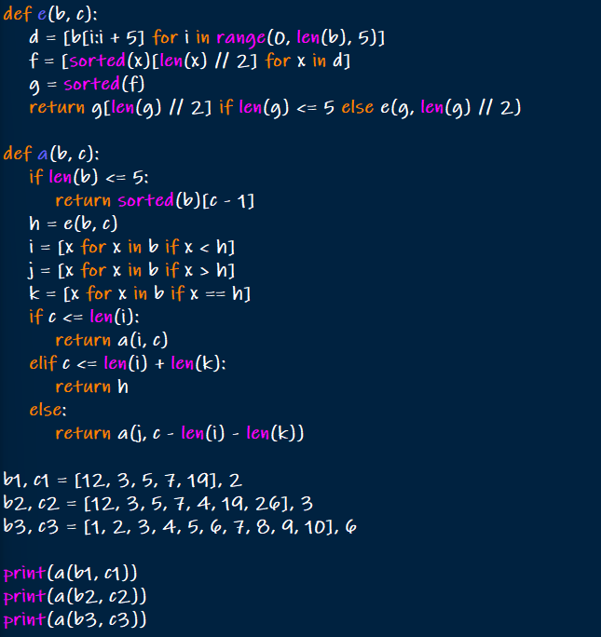

OUTPUT:

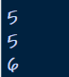

Closest pair:

CODE:

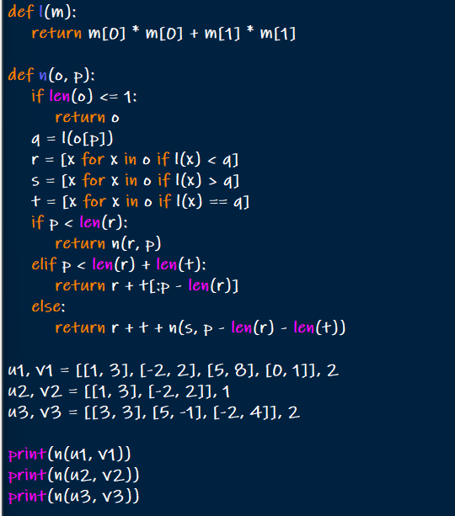

OUTPUT:

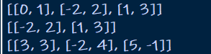

CODE:

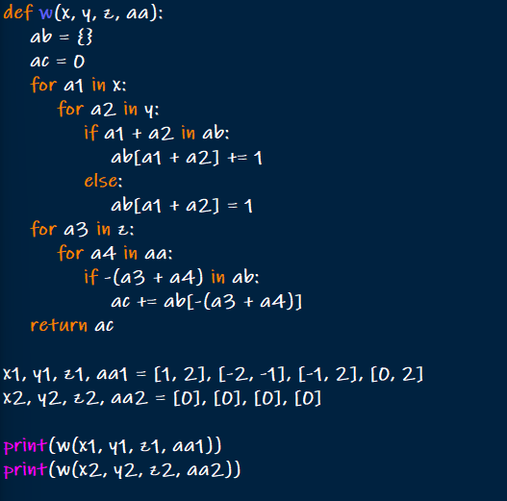

OUTPUT:

